Python practice String

248518 Gaurav B Raskar

Q.1.

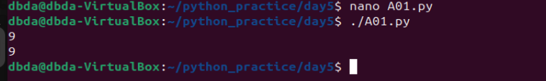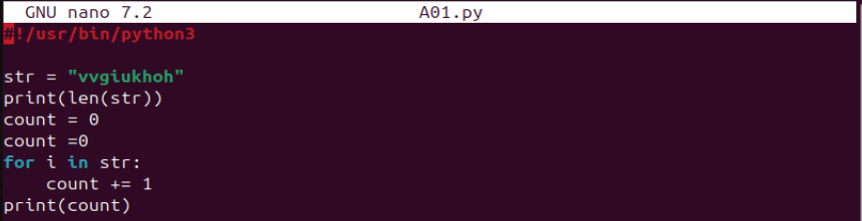

Q.4.

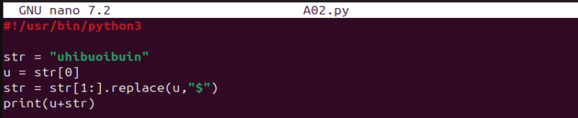

Q.5.

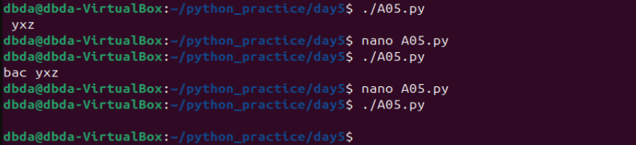

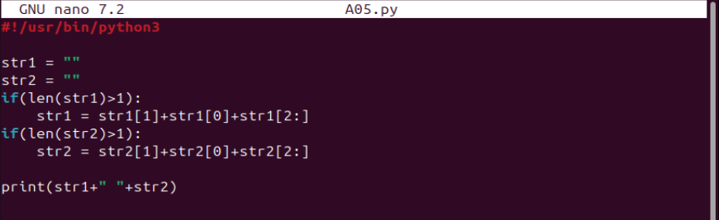

Q.6.

